Sentiment Analysis Using Large Language Model

Riya Jangam, Bharat Kale, Omkar Joshi

*¹Electronics & Telecommunication, Savitribai Phule Pune University, Pune, Maharashtra, India
riyajangam2002@gmail.com
²¹Electronics & Telecommunication, Savitribai Phule Pune University, Pune, Maharashtra, India
bkale775@gmail.com
³¹Electronics & Telecommunication, Savitribai Phule Pune University, Pune, Maharashtra, India
Omkarjoshi2610@gmail.com

ABSTRACT
This paper presents a novel approach leveraging Large Language Models (LLMs) for sentiment analysis in e-commerce websites. By employing deep learning algorithms, our model accurately categorizes product reviews into neutral, positive, or negative sentiments. Through the analysis of vast text data, including emails, chat transcripts, and social media comments, businesses can enhance brand reputation and customer service, thus improving overall goods and services. This research contributes to the field of opinion mining by offering an effective technique to extract sentiment from textual data, aiding organizations in understanding customer perceptions and preferences.

- INTRODUCTION

Sentiment analysis, or opinion mining, is a branch of NLP that employs machine learning to discern sentiments in text. LLMs, such as GPT-3, are pivotal in this field because they can comprehend and generate human-like text. Their pre-training on extensive textual data enables them to capture language nuances effectively, making them adept at tasks like sentiment analysis.
LLMs excel in sentiment analysis by contextualizing information, and considering surrounding words and phrases for more accurate predictions. As technology progresses, integrating LLMs in sentiment analysis enhances accuracy and enables more nuanced analyses, contributing to a deeper understanding of public sentiment in various domains.

Software Overview
Python IDLE –
Version: 3.9.5
Tk Version: 8.6.9
OS: Windows 11 Home Single Language (23H2)
OS Build: 22635.3139

Python v3.9.5
IDLE is an integrated development environment for Python, which has been bundled with the default implementation of the language since 1.5.2b1. It is packaged as an optional part of the Python packaging with many Linux distributions. It is completely written in Python and the Tkinter GUI toolkit.
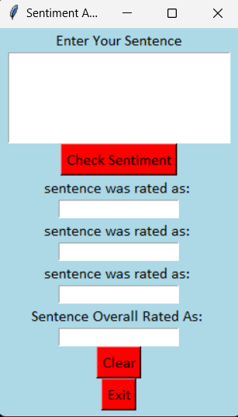

SYSTEM ARCHITECTURE
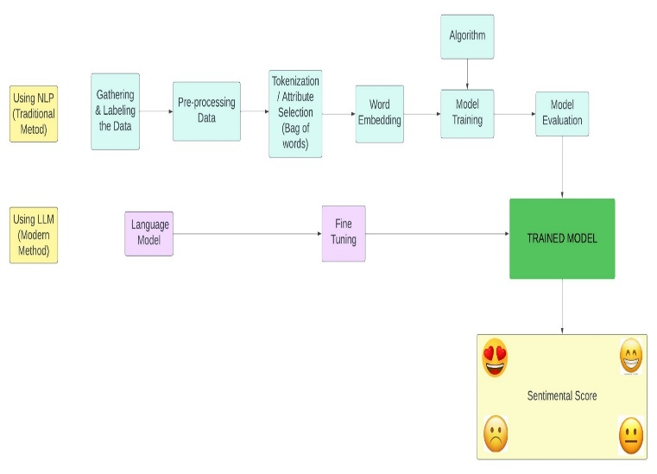

Functionality of system in two methods –

Using Natural Language Processing (Traditional Method)

- Data gathering involves collecting and labeling data to provide context for machine learning models.
- Pre-processing and tokenization clean and break down text data into individual words or tokens.
- Word embedding converts tokens into numerical representations capturing their meaning and context.
- Algorithms are step-by-step instructions crucial for solving computational tasks effectively.
- Model training teaches computers to understand and process language patterns for tasks like sentiment analysis.
- Model evaluation assesses the performance and generalization ability of trained models using metrics like accuracy and precision.
- Trained models apply learned knowledge to make predictions or classifications on new data.
- Sentiment scores provide numerical representations of text sentiment, condensing emotional tone into single values.

Using Large Language Model (Modern Method)
- Language modeling predicts next words based on preceding context, crucial for various applications.
- Fine-tuning enhances pre-trained models' performance for specific tasks or domains.
- Sentimental score quantifies text emotion into a single numerical representation.

- LITERATURE SURVEY
Sentiment analysis, at the nexus of natural language processing and machine learning, has advanced significantly with the rise of large language models like GPT-3. While early methods relied on rule-based systems and traditional ML, these models revolutionize sentiment analysis by leveraging contextual understanding and semantic intricacies from extensive pre-trained language representations. Transfer learning and fine-tuning techniques have been crucial in adapting these models to sentiment tasks, showing superior performance. Yet, challenges like ethical considerations and biases persist. Despite this, the integration of large language models in sentiment analysis finds diverse applications across domains, promising a future of ongoing research to enhance architectures, address ethical concerns, and explore new applications.

- FUTURE SCOPE
Enhancing the app's user interface by introducing additional features, customization options, and a more intuitive design is paramount to delivering an improved user experience. Furthermore, integrating real-time data streaming capabilities enables the analysis of sentiments from live sources like social media feeds, news articles, and customer reviews, ensuring the app remains current and pertinent. Additionally, expanding language support to include other languages enriches the app's versatility and accessibility to a broader user base. By integrating machine learning models, including pre-trained or custom-trained ones, we can bolster sentiment analysis accuracy and effectively handle a wider spectrum of expressions, thus augmenting the app's functionality and utility for users.

- CONCLUSION

The proposed design outlined in the report suggests the feasibility of constructing a sophisticated model proficient in precisely analysing the sentiment of given sentences. This model is envisioned to offer comprehensive insights by providing detailed breakdowns into positive, negative, and neutral sentiments, thus contributing to a more nuanced understanding of the conveyed emotions within the text.

- REFERENCES

- Call for code event from IBM - https://www.ibm.com/products/watsonx-ai
- Chain LIT and LLM - https://youtu.be/_S3usFpVJOM?si=oXyb-EwvsY7B4lB-
- Kaggle for dataset collection - https://www.kaggle.com/datasets/vedatgul/nlp-tweets/data
- What do LLMs Know about Financial Markets? A Case Study on Reddit Market Sentiment Analysis - https://ieeexplore.ieee.org/document/9498965
- Sentiment Analysis Using Machine Learning Algorithm - https://ieeexplore.ieee.org/document/9498965
- Instruct-FinGPT: Financial Sentiment Analysis by Instruction Tuning of General-Purpose Large Language Models - https://papers.ssrn.com/sol3/papers.cfm?abstract_id=4489831

